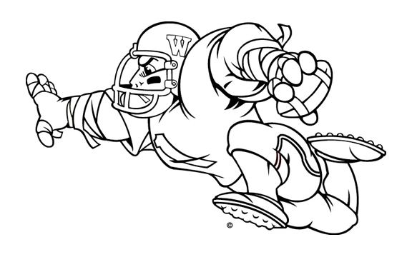
The Indianapolis Association of Wabash Men
invites you to join other Wabash College fans for a pre-game tailgate ‘Bash!

Wabash College
vs.
Franklin College

Date: Saturday, September 9, 2006
Game time: 1:00 PM
Tailgate starts at 11:00 AM
Location: See map below and at www.franklincollege.edu
Please bring a side dish – hamburgers and hot dogs will be provided.

To make sure we have enough food and beverage for everyone, please let us know if you plan to attend. Email at bazzanih@wabash.edu or call 765-361-6360.

